Step 1:

Prometheus monitoring URL

<http://10.9.202.112:9090/graph>

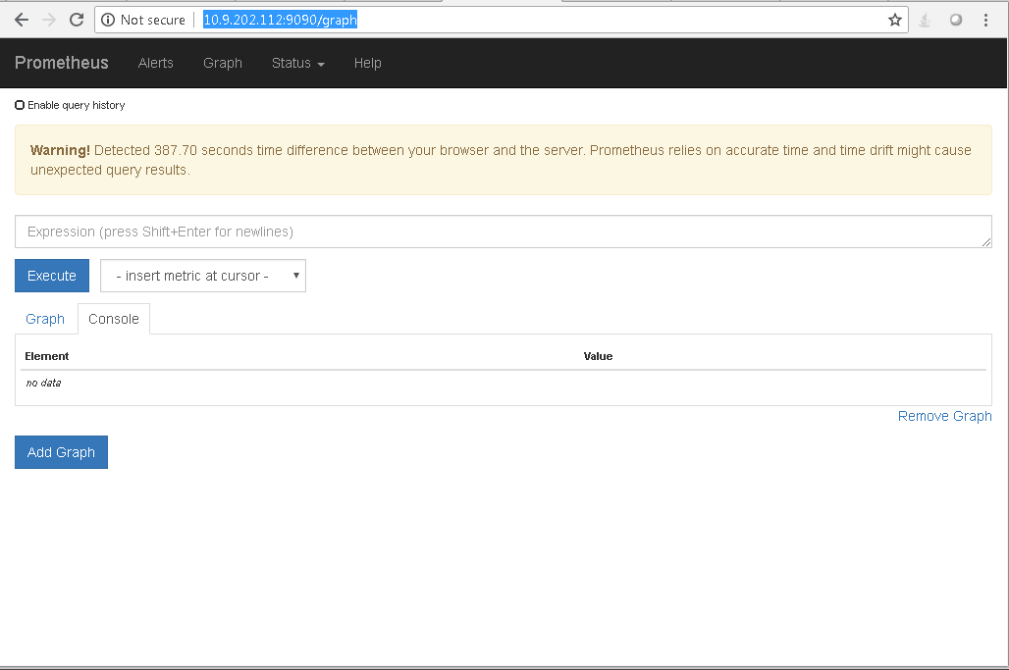

Step 2: Click on Insert Metric at cursor

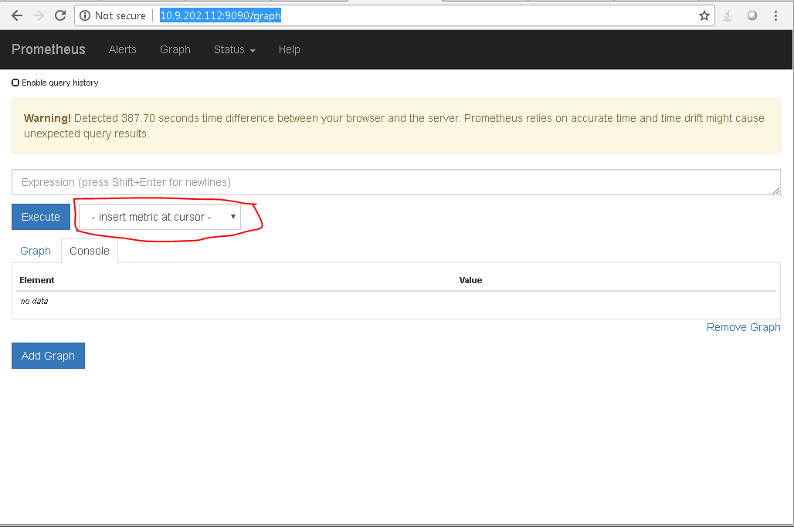

Step 3:

Select Any metric Start with :wmi” ( for windows metric ) from Insert matric and I have selected “wmi_logical_disk_free_bytes”

Select Any Node start with Node for Linux machine

Select Any Prometheus for ( local Server)

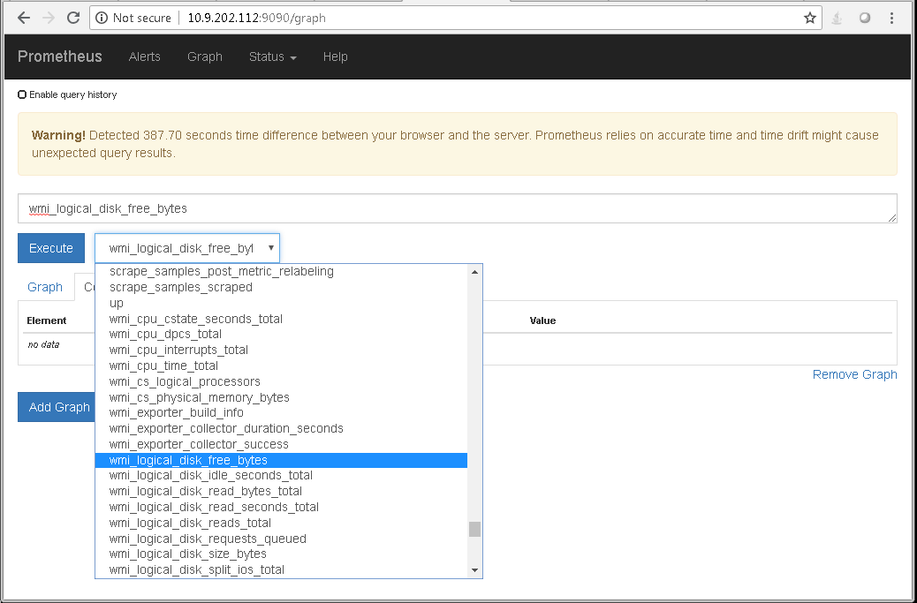

And then click Execute button, Prometheus will execute and get the details

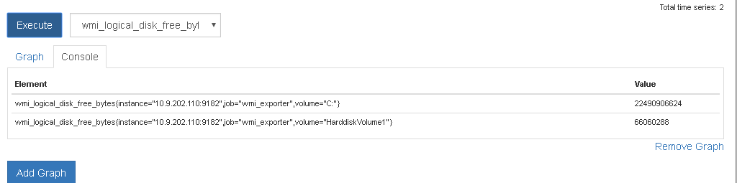

Step 4:

Select the Graph

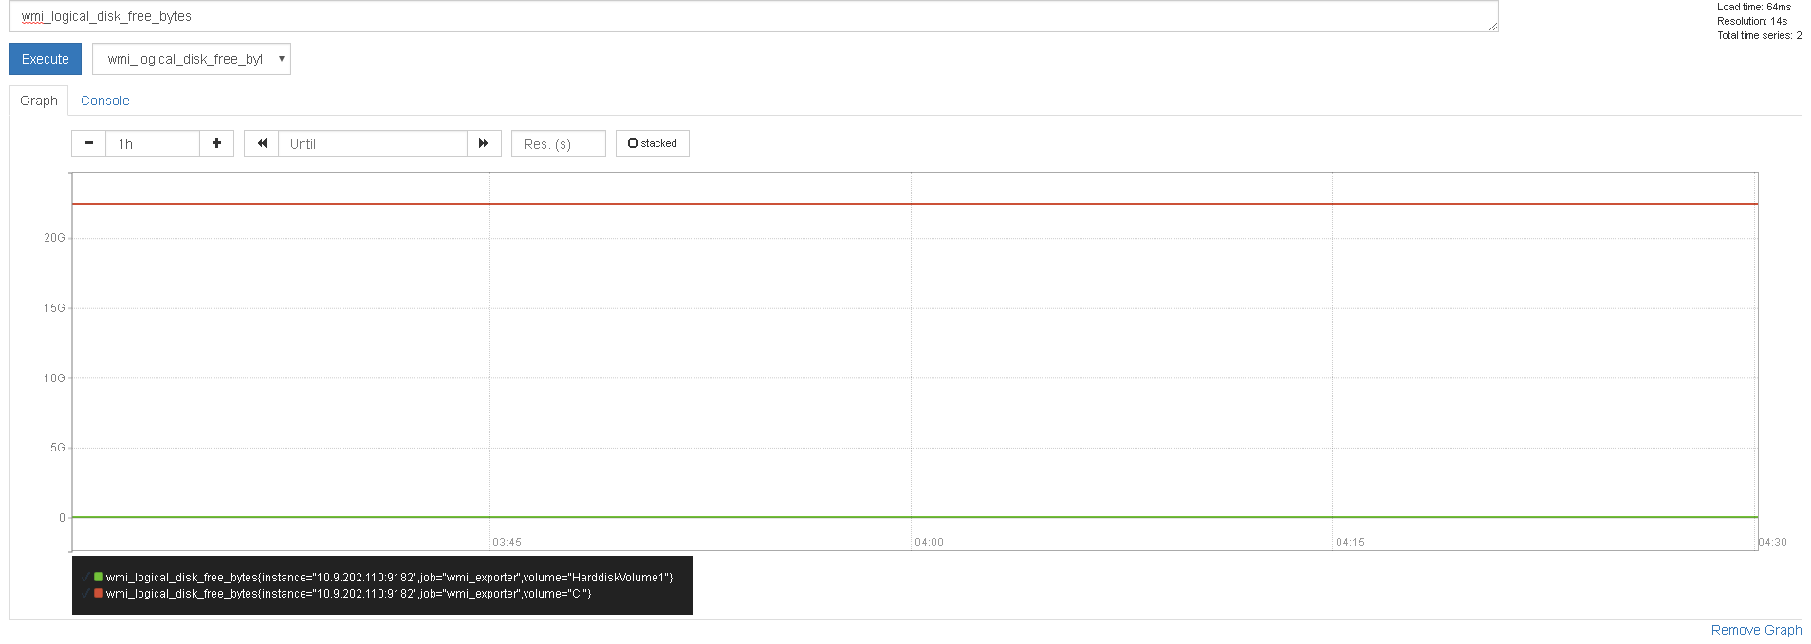

Step1 :

<http://10.9.202.112:3000>

username: admin

Password : admin

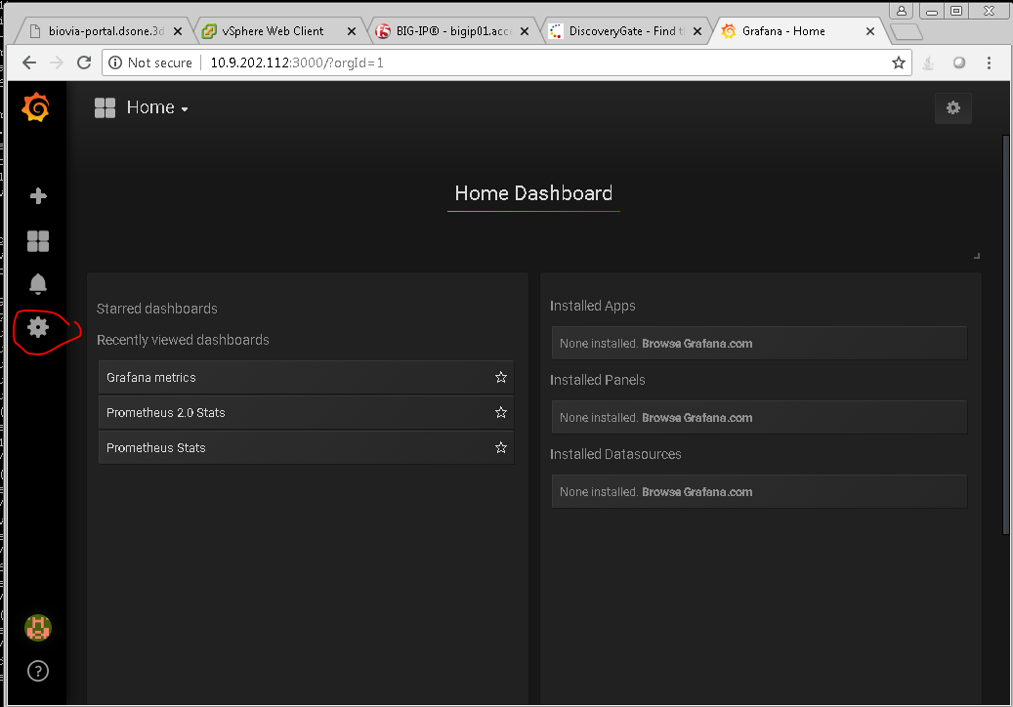

SSelect Home > Select setting > Datasoruces > Select Windows node1 >

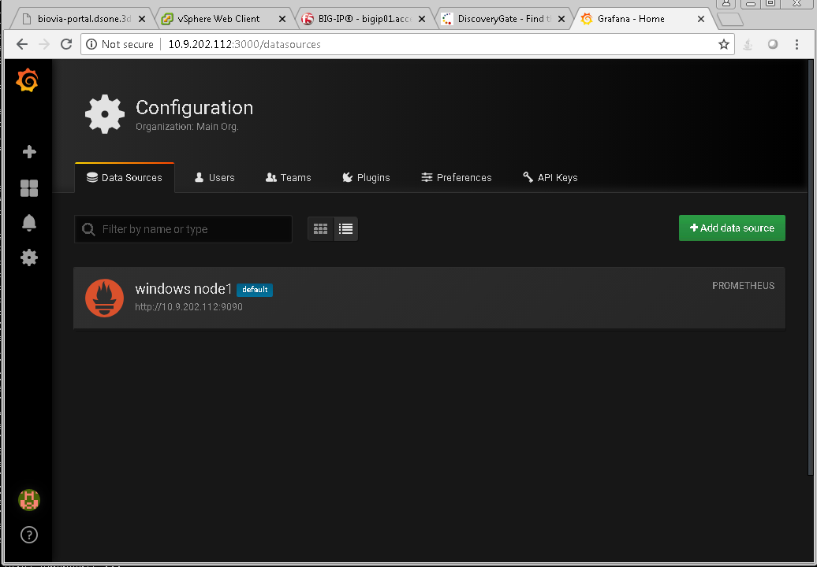

Then select Dashboard

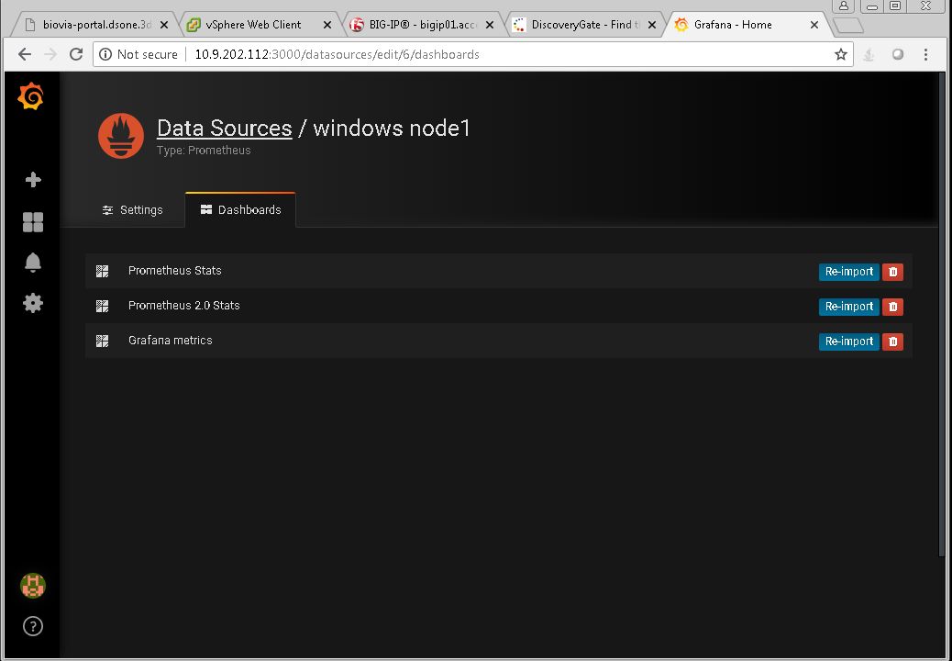

Then select Prometheus 2.0 stats then you will get samples

Select any one of the samples and edit it

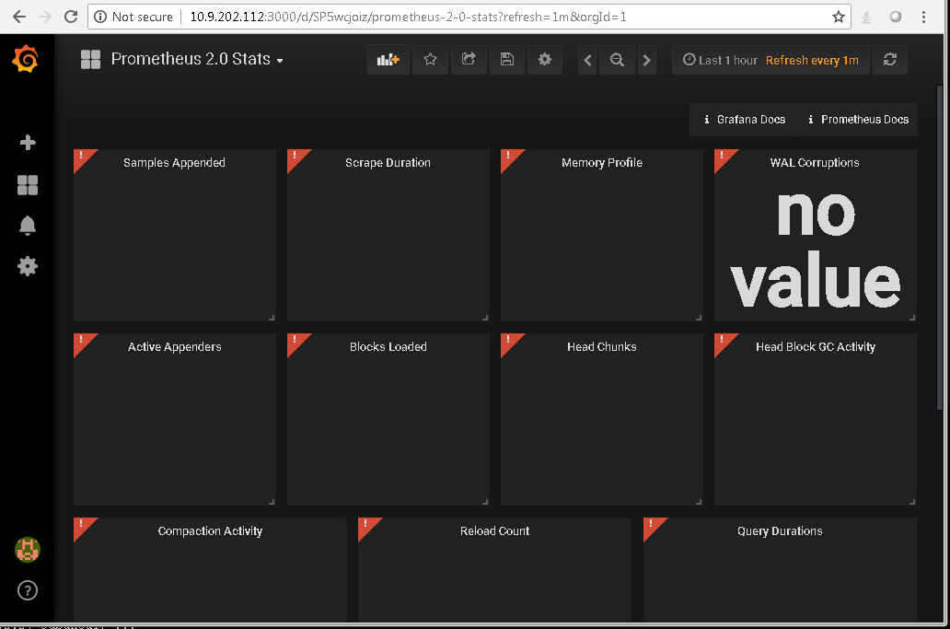

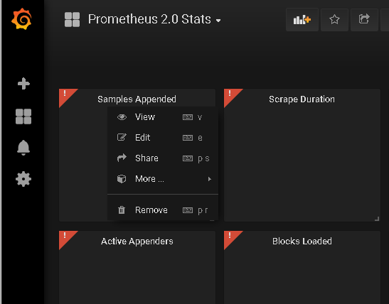

Select EDIT

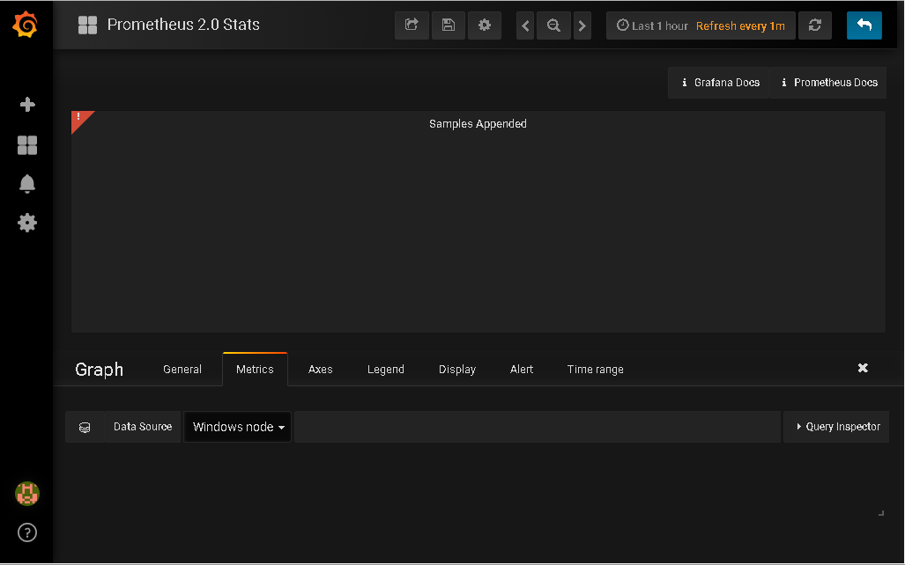

Select Metrics > in Datastore > Select windows node 1

There we can add the query

e.g below I typed vmi and will get windows related services.

